SMT. ARUNA ASAF ALI GOVT. P. G. COLLEGE, KALKA
Session 2021-22
Name of the activity:- 7th International Yoga Day
Organizing Department/ Committee: As per orders from DC Panchkula
Date: 21.06.2021
Description:- Celebrated Yoga Day and participated in the live Yoga session By Hon’ble Prime Minister Sh. Narendra Modi Ji.
No. of students participated: 20

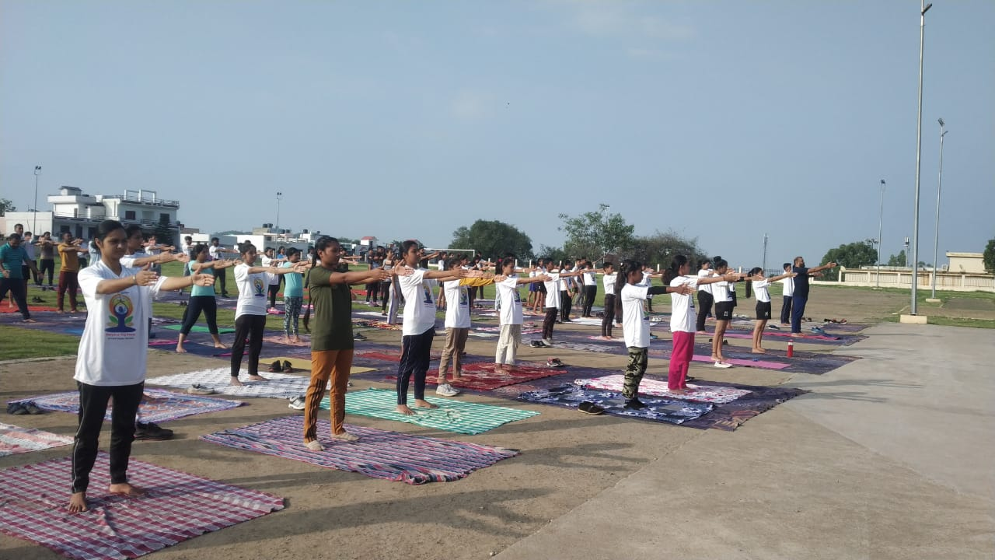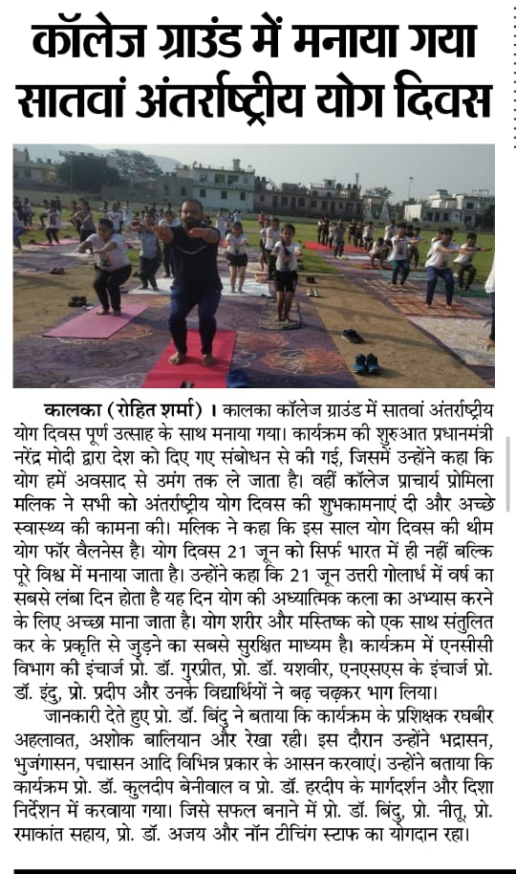

NCC Incharge Principal

SMT. ARUNA ASAF ALI GOVT. P. G. COLLEGE, KALKA
Session 2021-22

Name of the activity: Online disaster management capsule
Organizing Department/ Committee: NITSRDR, Ramgarh, Haryana
Date: 25.06.2021
Description: Three SW cadets attended one day online disaster management capsule
No. of students participated: 3

 |  | Nominal roll
S.NO | Name of institution | Regt no | Name of cadet | whatsapp mobile no. | remarks
1 | Govt college kalka | HR/SWA/19/224394 | Sunita kumaei meena | 8950556635
2 | Govt college kalka | HR/SWA/19/224381 | Gagandeep | 9350427792
3 | Govt college kalka | HR/SWA/19/224392 | Kamolika | 9306552660

NCC Incharge Principal

SMT. ARUNA ASAF ALI GOVT. P. G. COLLEGE, KALKA
Session 2021-22

Name of the activity:- Clean Campus, Green Campus
Organizing Department/ Committee: Govt. College Kalka & HGCTA, Haryana
Date: 05.08.2021
Description: Inauguration of Clean Campus, Green Campus campaign by Honorable Education minister of Haryana, Shri Kanwar Pal Gujjar
No. of students participated: 6

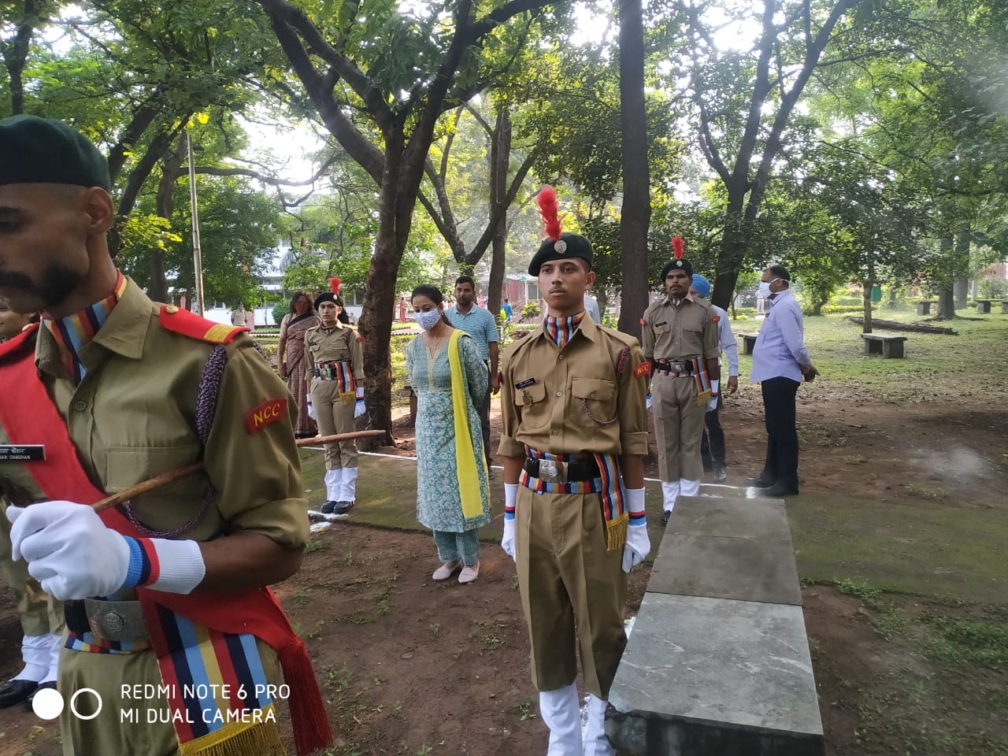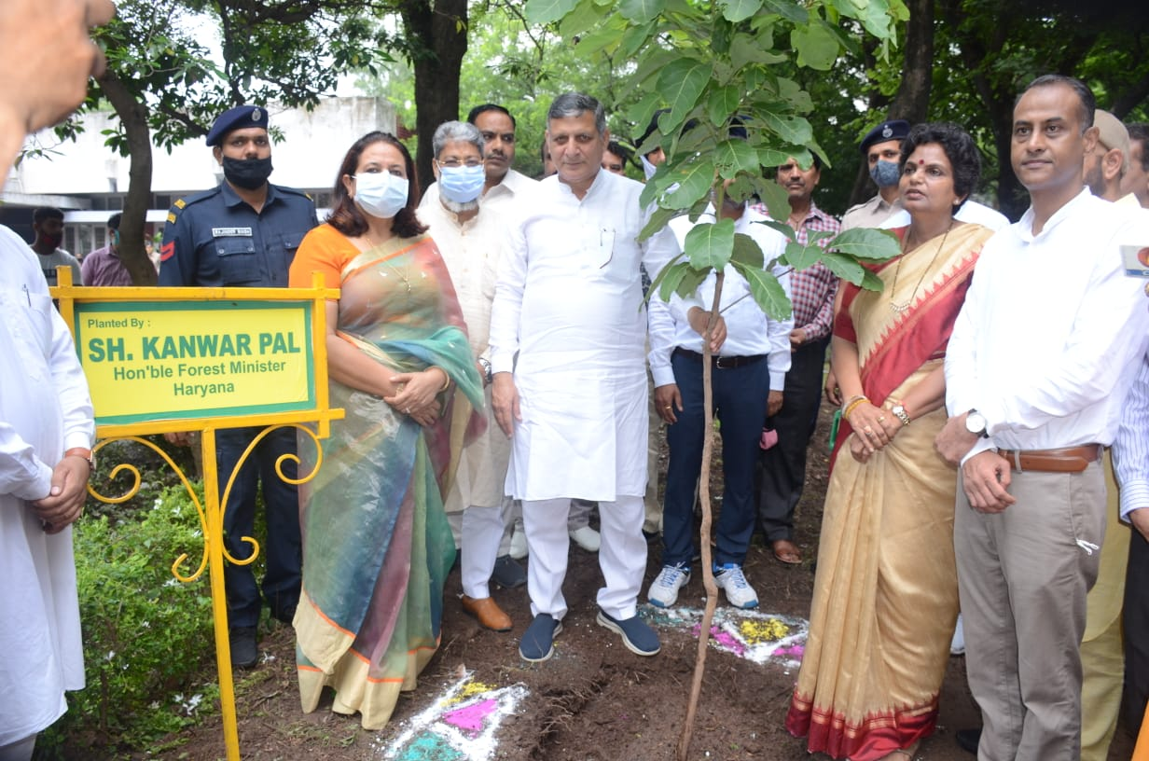

NCC Incharge Principal
SMT. ARUNA ASAF ALI GOVT. P. G. COLLEGE, KALKA
Session 2021-22
Name of the activity:- Online poetry competition
Organizing Department/ Committee: 2 Har Bn NCC, Sonepat
Date: 10.08.2021
Description: :- Online poetry competition on the theme "CLEAN INDIA GREEN INDIA'' - non use of single use plastic conducted by 2 Har Bn NCC, Sonepat on behalf of NCC GP HQ Ambala
No. of students participated: 2
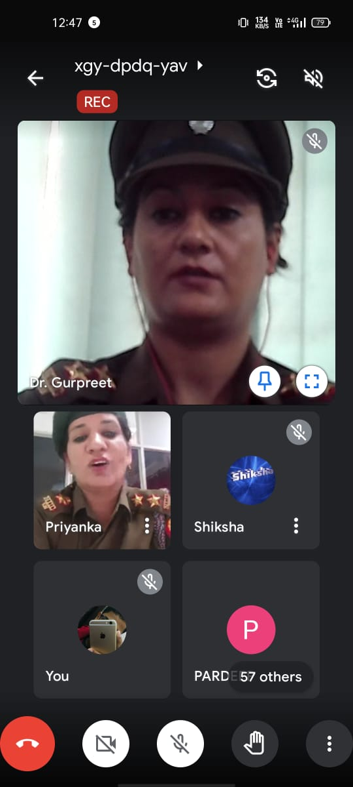

NCC Incharge Principal

SMT. ARUNA ASAF ALI GOVT. P. G. COLLEGE, KALKA
Session 2021-22
Name of the activity:- Celebration of Independence Day
Organizing Department/ Committee: NCC (Girls) Unit
Date: 15.08.2021
Description: 75th Independence Day was celebrated in the college campus as well as all the cadets were appreciated by SDM, Kalka for March past.
No. of students: 30

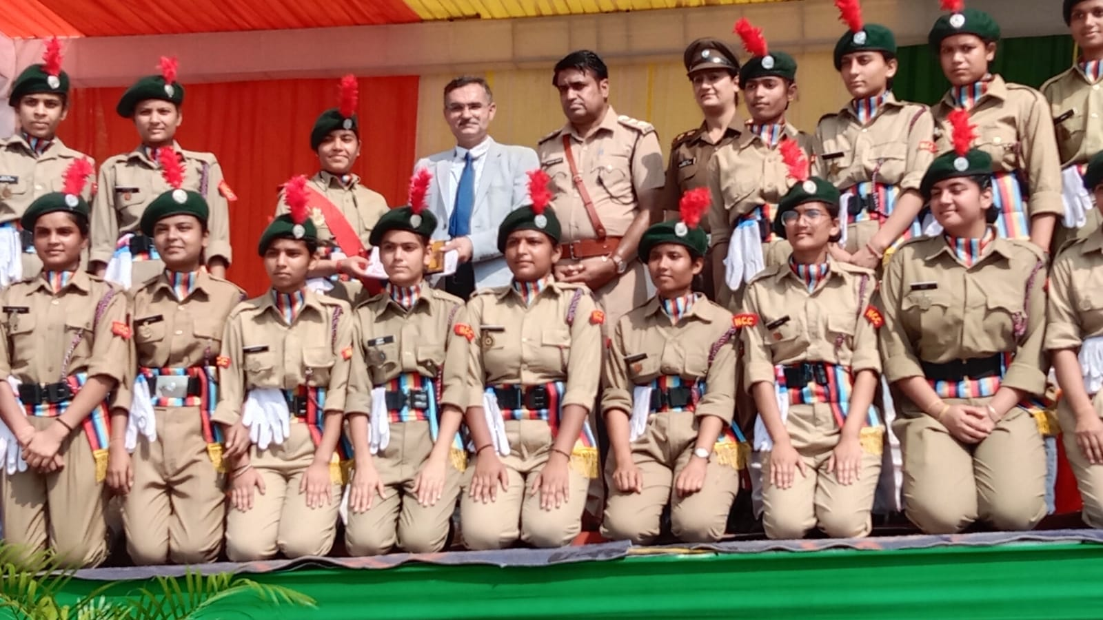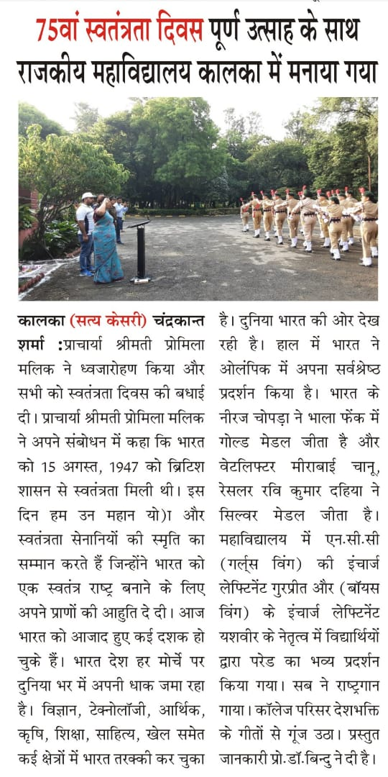

NCC Incharge Principal

SMT. ARUNA ASAF ALI GOVT. P. G. COLLEGE, KALKA
Session 2021-22

Name of the activity:- Freedom Run
Organizing Department/ Committee: Nehru Yuva Kendra Sangathan, Panchkula
Date: 18.09.2021
No. of participating students: 10

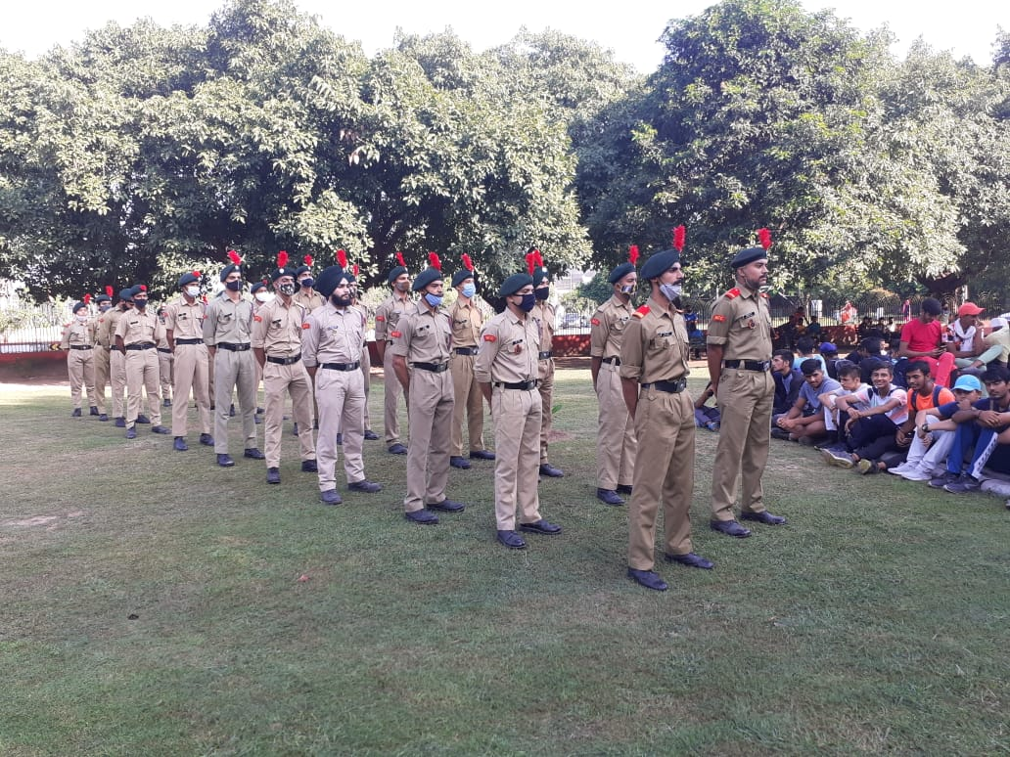

NCC Incharge Principal

SMT. ARUNA ASAF ALI GOVT. P. G. COLLEGE, KALKA
Session 2021-22

Name of the activity:- Gandhi Jayanti
Organizing Department/ Committee: NCC Unit
Date: 01.10.2021
Description: On the occasion of Gandhi Jayanti, NCC cadets paid tribute to Mahatma Gandhi and a cleanliness drive was organized by NCC unit of the college. On this occasion principal madam encouraged students for the importance of cleanliness.
No. of participating students: 10

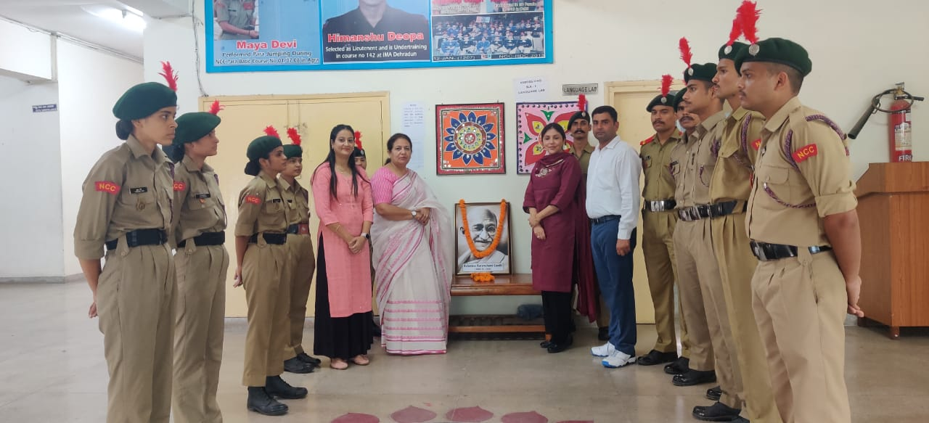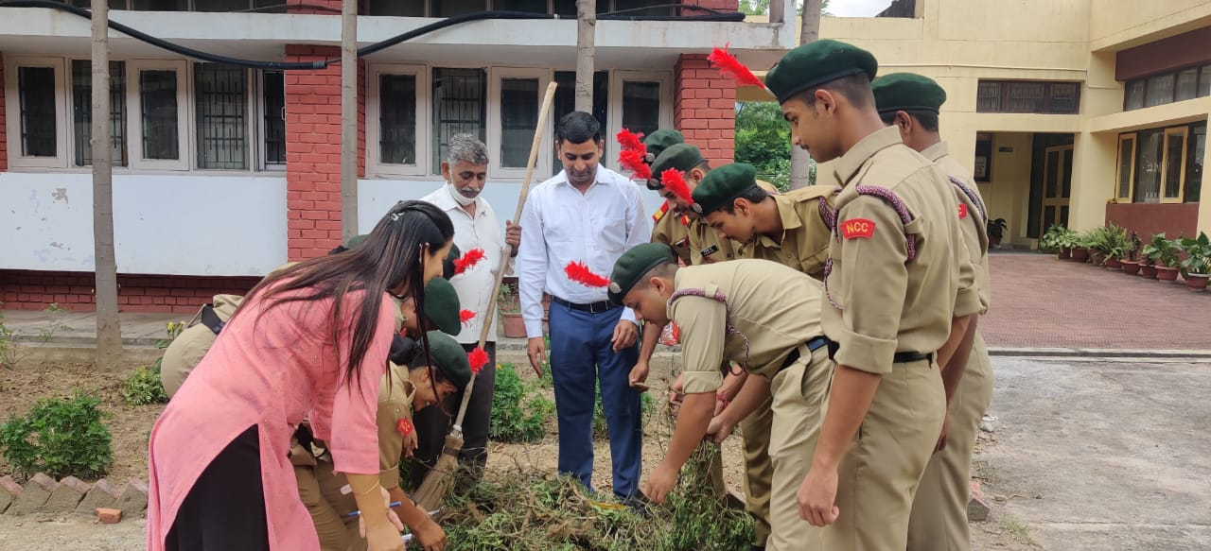

NCC Incharge Principal

SMT. ARUNA ASAF ALI GOVT. P. G. COLLEGE, KALKA
Session 2021-22

Name of the activity:- NCC Cadets Physical Fitness Test and Personal Interview.
Organizing Department/ Committee: NCC Unit
Date: 22.10.2021
Description: For the new session, i.e. 2021-22, enrollments of new NCC were done. Around 45 girl candidates participated for selection of 19 vacancies in NCC girls wing for new session. This process included physical fitness test of the students followed by personal interview.
No. of participating students: 45

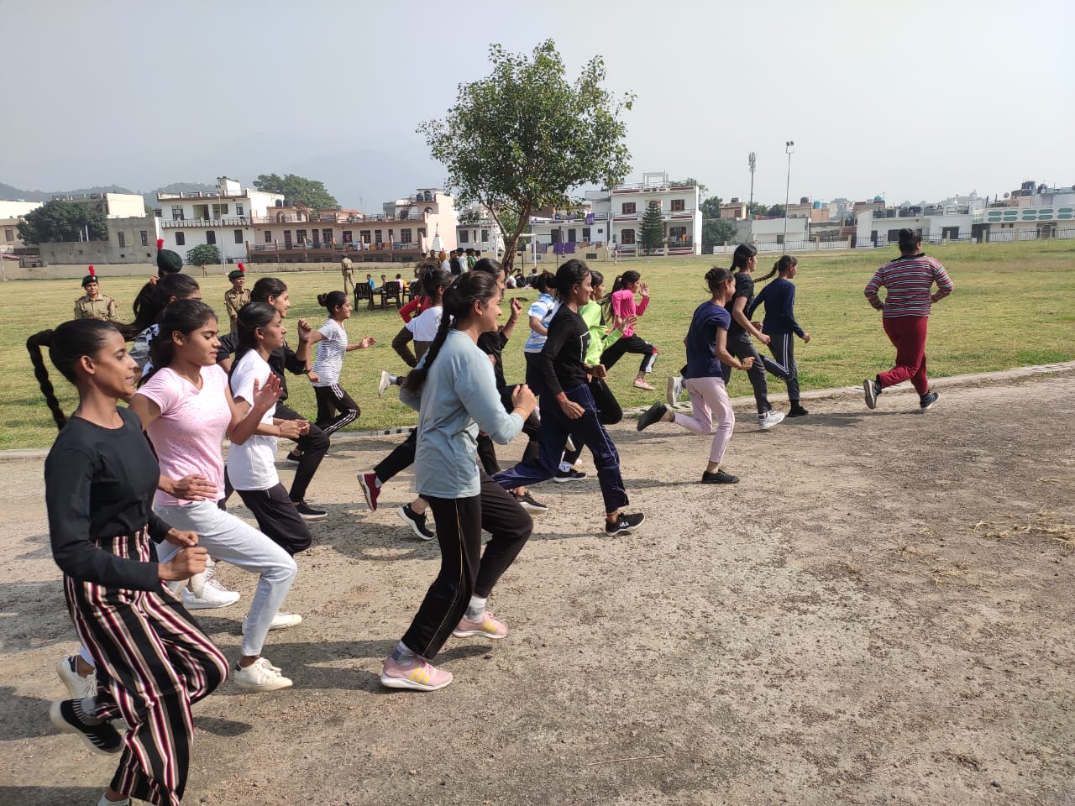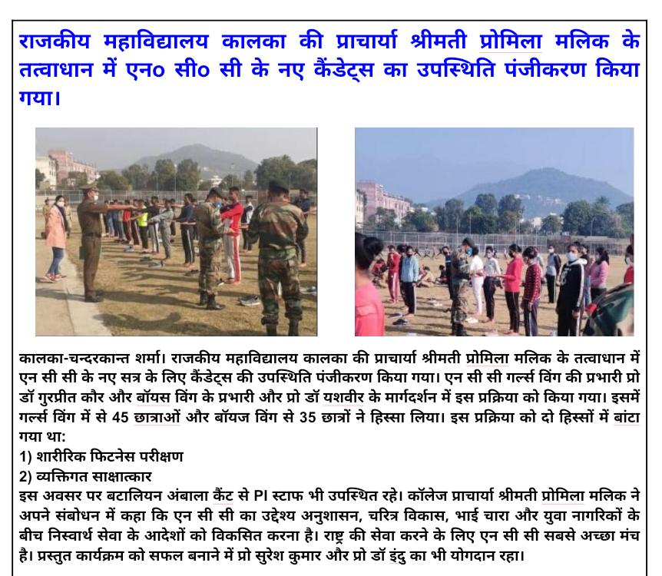

NCC Incharge Principal
SMT. ARUNA ASAF ALI GOVT. P. G. COLLEGE, KALKA
Session 2021-22
Name of the activity:- Annual Training Camp -143
Organizing Department/ Committee: 2 Haryana Battalion, Ambala Cantt
Date: 26.10.2021 to 30.10.2021
Description: Annual Trg Camp (ATC-143) for second year Senior Div NCC cdts was held at Govt. P G College Sec-1, Panchkula from 26 Oct to 30 Oct 2021
No. of participating students: 13

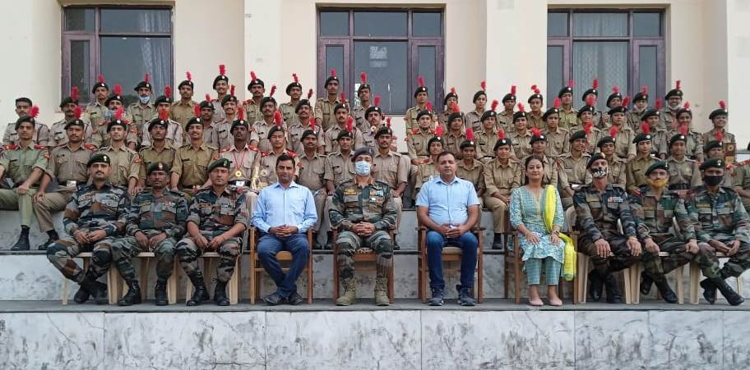

NCC Incharge Principal

SMT. ARUNA ASAF ALI GOVT. P. G. COLLEGE, KALKA
Session 2021-22
Name of the activity:- Annual Training Camp -144
Organizing Department/ Committee: 2 Haryana Battalion, Ambala Cantt
Date: 26.10.2021 to 01.11.2021
Description: Annual Trg Camp (ATC-144) for third year Senior Div NCC was held at S D College Ambala Cantt from 26 Oct to 01 Nov 2021.
No. of participating students: 23
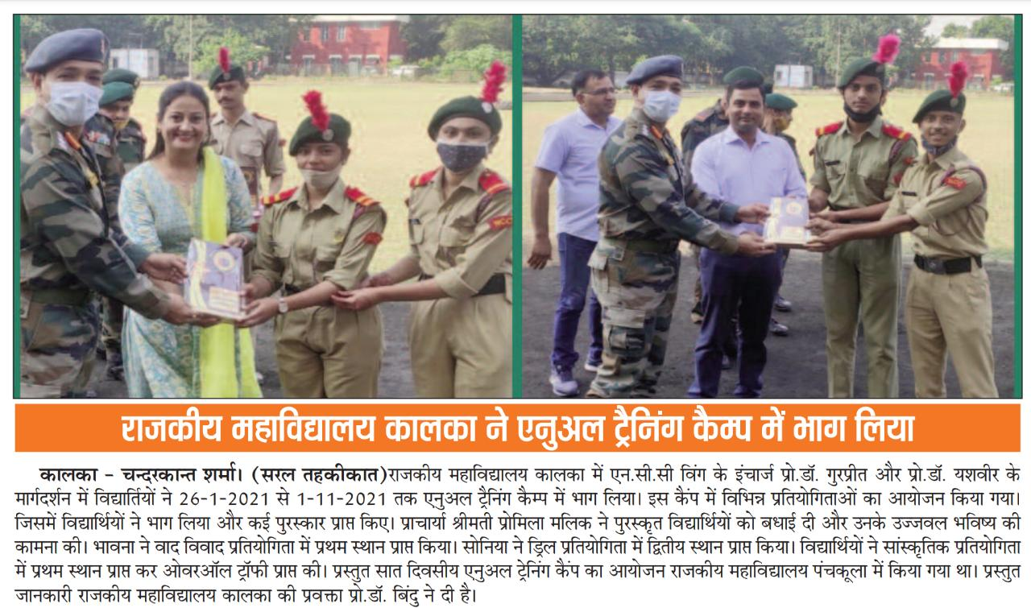

NCC Incharge Principal

SMT. ARUNA ASAF ALI GOVT. P. G. COLLEGE, KALKA
Session 2021-22

Name of the activity:- 73rd NCC Raising Day
Organizing Department/ Committee: NCC Unit
Date: 28.11.2021
Description: 73rd NCC raising celebrated in Govt College Kalka. The celebration started with NCC song followed by pledge taking ceremony. PI staff from 2 Har BN Ambala Cantt was also present. Programme ended with a rally themed “Save Environment”.
No. of participating students: 15
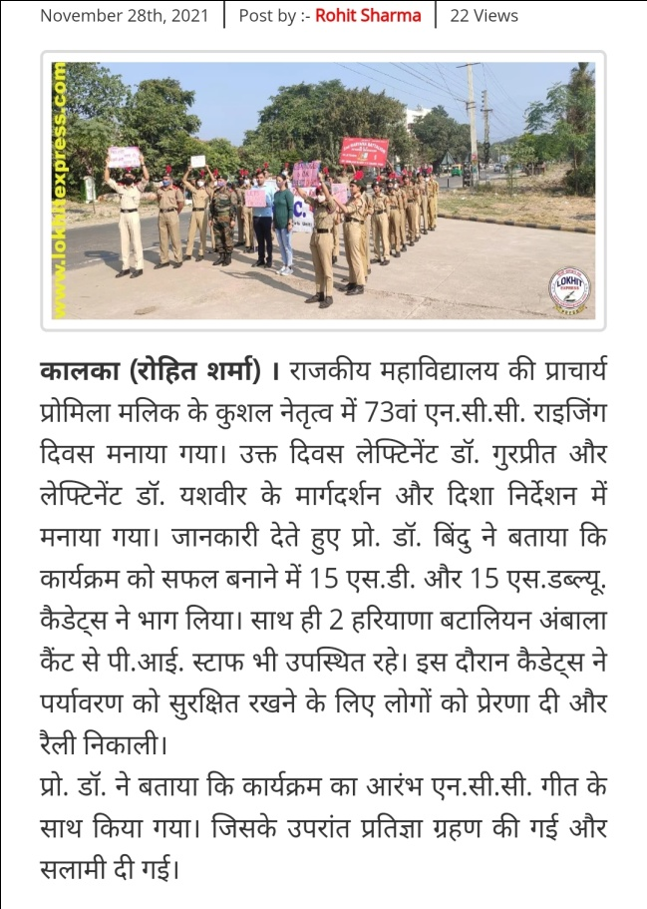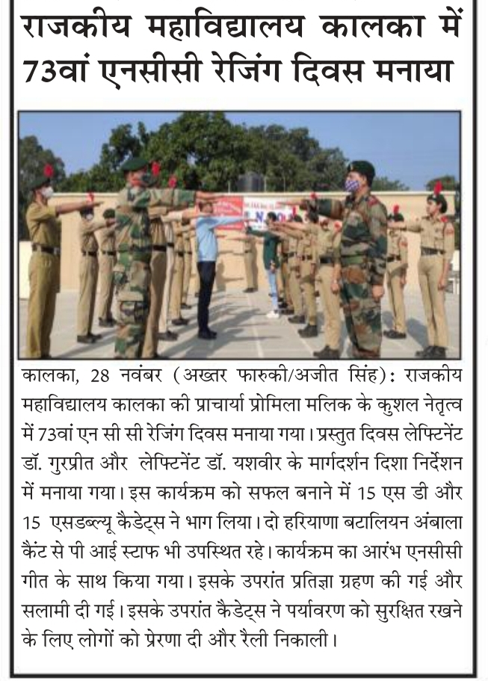

NCC Incharge Principal
SMT. ARUNA ASAF ALI GOVT. P. G. COLLEGE, KALKA
Session 2021-22

Name of the activity: Republic Day Celebration
Organizing Department/ Committee: NCC (Girls) Unit
Date: 26.01.2022
Description: 73rd Republic day was celebrated in the college campus as well as all the cadets were appreciated by SDM, Kalka for march past.
No. of students: 30

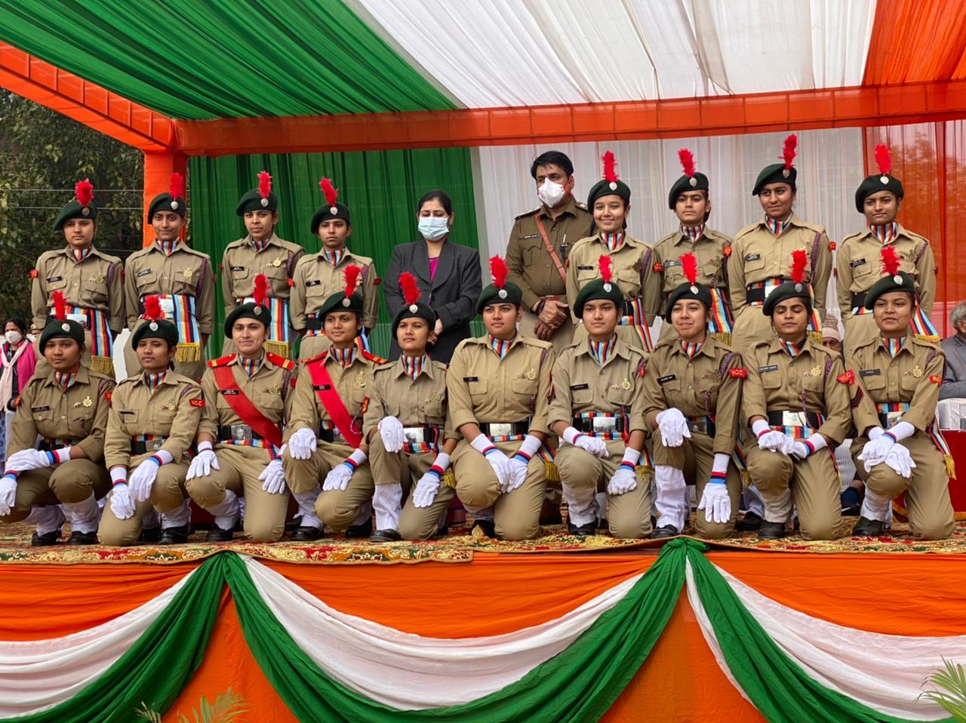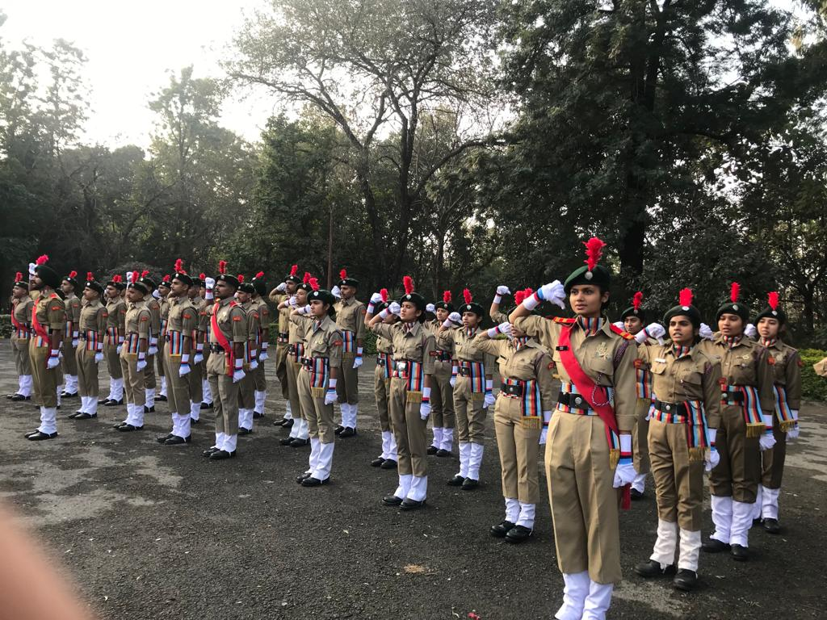

NCC Incharge Principal
SMT. ARUNA ASAF ALI GOVT. P. G. COLLEGE, KALKA
Session 2021-22

Name of the activity:- Mock Test
Organizing Department/ Committee: NCC (Girls) Unit
Date: 07.02.2022 & 08.02.22
Description: Two mock test papers for all cadets were conducted to check potential / ability of cadets and to prepare them for “B” & “C” Certificate exam.
No. of students: 36

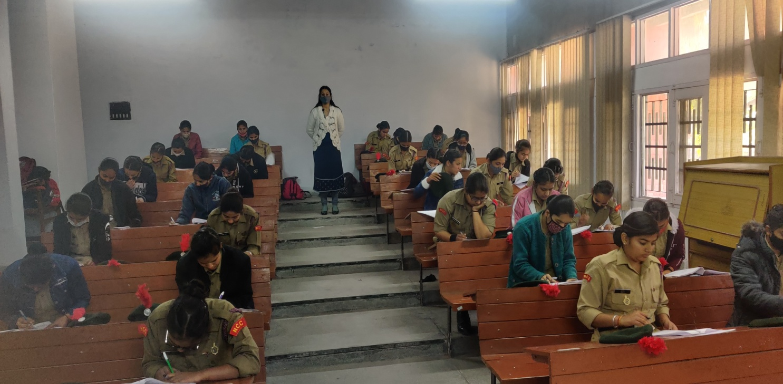

NCC Incharge Principal

SMT. ARUNA ASAF ALI GOVT. P. G. COLLEGE, KALKA
Session 2021-22

Name of the activity:- Basketball Tournament
Organizing Department/ Committee: Govt. College Kalka & DGHE
Date: 09.02.22 to 13.02.22
No. of students: 4

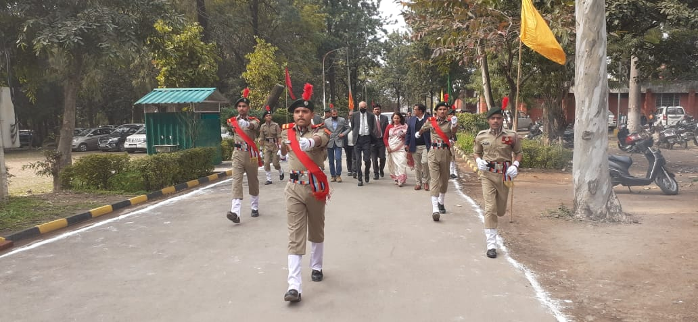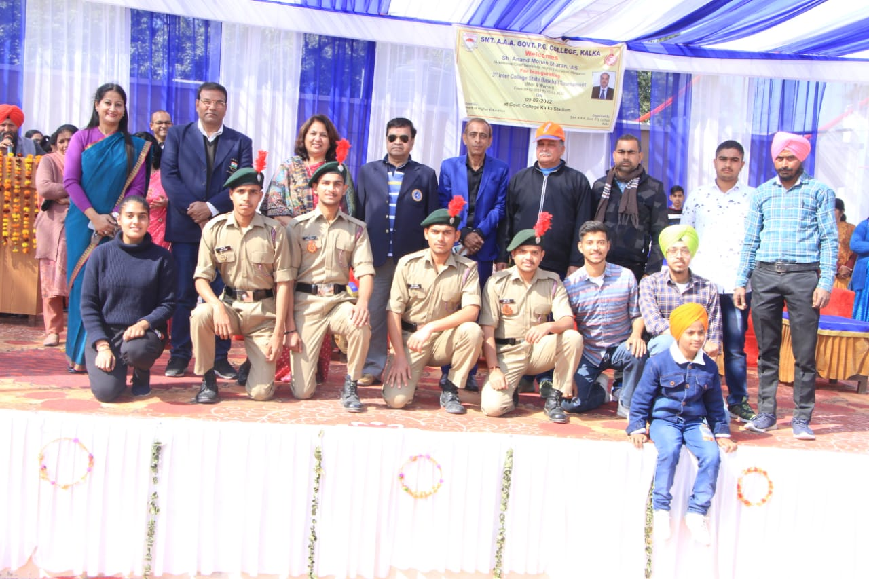

NCC Incharge Principal

