PLACEMENT CELL ACTIVITIES (SESSION 2021-22)
Sr. no. | Activity | Key Speaker | Date | No. of Students | Images
1. | Extension Lecture on “Job Prospects and Career Opportunities in Political Science”. | Mr. Subhash  Associate Prof. In Political Science, Govt. P.G. College, Sector-1, Panchkula (Haryana) | 29.11.2021 | 158 | 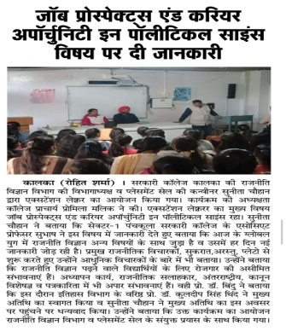
2. | Extension Lecture on “Job Prospects and Career Opportunities in Psychology after Graduation and Post Graduation”. | Prof. (Dr.) Shruti Shourie  Deptt. of Psychology  D.A.V. college, Sector-10, Chandigarh | 10.12.2021 | 140 | 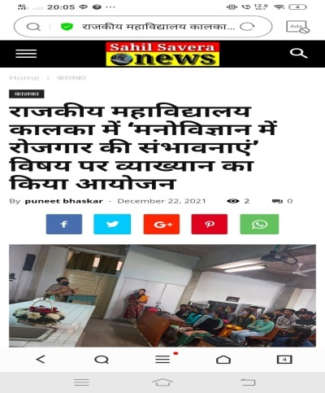
3. | Extension Lecture on “Career Opportunities in English Literature & Language”. | Prof. (Dr.) Deepti Gupta, Deptt. Of English and Cultural Studies, Panjab University, Chandigarh | 22.12.2021 | 190 | 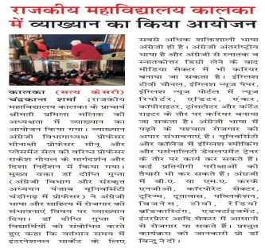
4. | Webinar on “Job Prospects and Career Opportunities in Hindi after Graduation and Post Graduation”. | Prof. (Dr.) Ashok Kumar, Deptt. Of Hindi, Panjab University, Chandigarh. | 11.1.2022 | 149 | 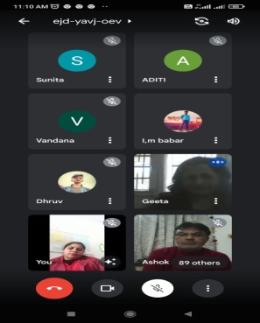
5. | Webinar on “Job Prospects and Career Opportunities in Economics after Graduation and Post Graduation”. | Dr. Smita Sharma, Assistant Prof. in Economics Department, Panjab University, Chandigarh | 12.1.2022 | 98 | 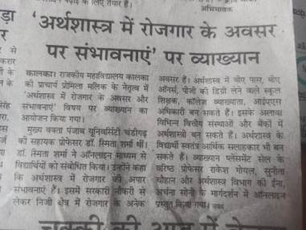
6. | Webinar on “Job Prospects and Career Opportunities in Computer Science”. | Prof. (Dr.) Kuljit Kaur Chahal, Deptt. Of Computer Sc. , Guru Nanak Dev University, Amritsar, Panjab | 17.1.2022 | 67 | 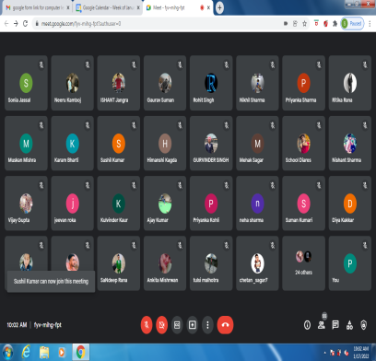
7. | Webinar on “Applied Mathematics and Career Perspectives”. | Dr. Sushil Yadav, Associate Prof., Deptt. Of Mathematics, Maharaja Agrasen College, University of Delhi. | 19.1.2022 | 60 | 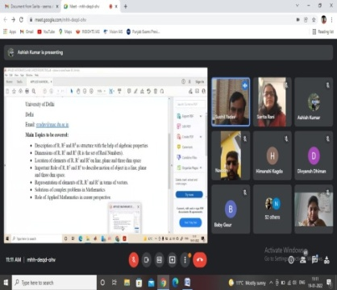
8. | Placement of 5 Students in Utkarsh Small Finance Bank | Utkarsh Small Finance Bank | 12 .01.2022 | 20
9. | Webinar on “Job Prospects and Career Opportunities in Public Administration”. | Prof. Dr. Rajkumar Siwach, Deptt. Of Public Administration, Ch. Devi Lal University Sirsa, Haryana | 20.1.2022 | 40 | 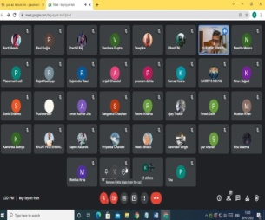
10. | Webinar on “Job Prospects and Career Opportunities in Geography”. | Prof. Dr. Vishwa B.S. Chandel, Deptt. Of Geography, Panjab University, Chandigarh | 15.1.2022 | 35 | 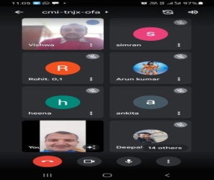
11 | Webinar on “Job Prospects and Career Opportunities in History after Graduation and Post Graduation”. | Prof. Dr. G.C Chauhan, Deptt. Of History, Panjab University, Chandigarh | 22.1.2022 | 67 | 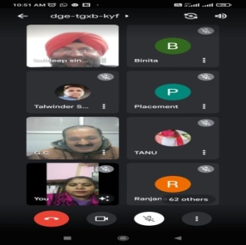
12. | Webinar on “Job Prospects and Career Opportunities in Chemistry after Graduation and Post Graduation”. | Dr. Deepak Kumar Aneja, Assistant Prof. Deptt. Of Chemistry, Ch. Bansi Lal University, Bhiwani, Haryana | 22.01.2022 | 58 | 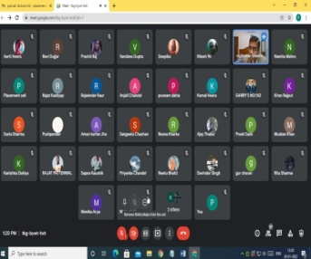
13. | Webinar on “Job Prospects and Career Opportunities in Sanskrit after Graduation and Post Graduation”. | Dr. Satyadev Nigamalnkar  Prof. & Head of Department, Shradhanand vedic Shodh Sansthan, Gurukul Kangri University, Haridwar | 24.01.2022 | 45 | 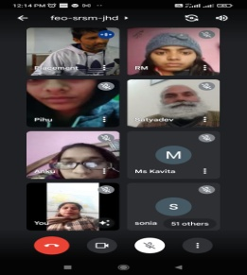
14. | Webinar on “Job Prospects and Career Opportunities in Physical Education” . | Prof. (Dr.) Dolly  Deputy Director, Deptt. Of Physical Education  Panjab University, Chandigarh | 25.01.2022 | 84 | 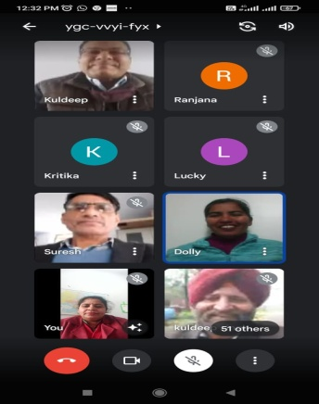
15. | Webinar on “Job Prospects and Career Opportunities in Physics after Graduation and Post Graduation”. | Dr. Suman Mahendra  Associate Professor, Deptt. Of Physics, Kurukshetra University, Kurukshetra | 25.01.2022 | 31 | 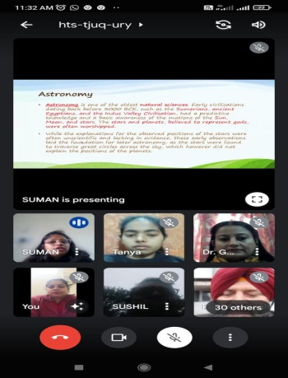
16. | Webinar on “Job Prospects and Career Opportunities in Commerce after Graduation and Post Graduation”. | Prof. (Dr.) Tejinder Sharma  Deptt. of Commerce, Kurukshetra University, Kurukshetra | 28.01.2022 | 145 | 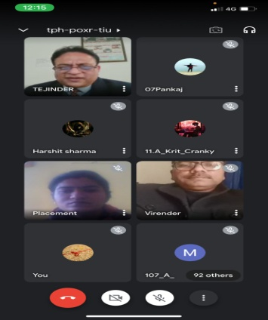
17. | Webinar on “Job Prospects and Career Opportunities in Zoology after Graduation and Post Graduation”. | Dr. Anupam Mittal  Assistant Professor  Department of Translational and Regenerative Medicine, PGIMER Chandigarh | 03.02.2022 | 30 | 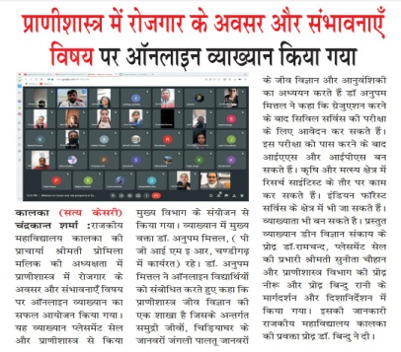
18. | Webinar on “Job Prospects and Career Opportunities in Punjabi after Graduation and Post Graduation”. | Prof. (Dr.) Gurmej Singh  Associate Professor, Deptt. of Punjabi, Shri Guru Govind Singh College, Sector-26 Chandigarh | 04.02.2022 | 63 | 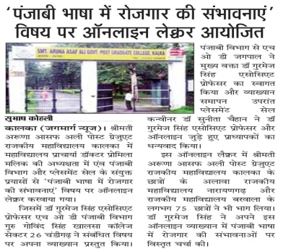
19. | Extension Lecture on “Job Prospects and Career Opportunities after Graduation and Post Graduation”. | Prof. (Dr.) Kuldeep Singh Thind  Associate Prof. In History (Retd.), CP-255, sector-105, Mohali (Punjab) | 08.02.2022 | 170 | 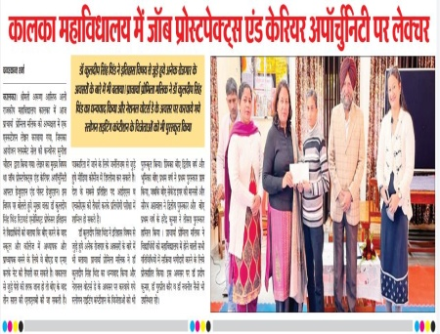
20. | Webinar on “Interview Skills”. | Mrs. Benu Rao, Director, Mrs. Benu rao Academy, SCO-22, 2nd Floor, Sector-11, Panchkula | 15.02.2022 | 88 | 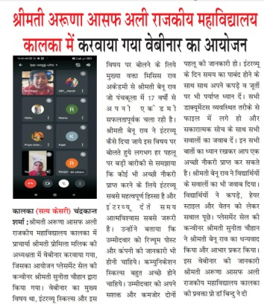
21. | Webinar on “How to Prepare Resume”. | Mr. Gurpreet Singh  Head, Training, Learning & Development Institute of Professional Banking, SCO-11, Sec-11 Panchkula | 18.02.2022 | 45 | 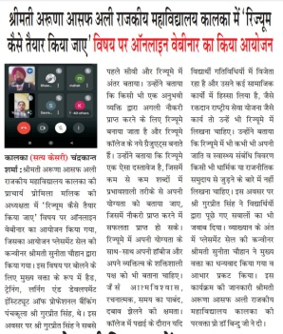

Activities organised by Placement Cell in collaboration with concerned Departments.

