Activity Report of Celebration of Day’s Committee for the session 2024-25

S. No. | Name of the activity | Objective | Date on which activity was conducted | No. of participants | Outcome of activity
1 | Celebration of Sardar Vallabhai Patel Jayanti  (essay writing competition) | To make the students aware about his contribution in uniting the nation and building a strong India | 26-10-2024 | 34 | Students performed very well in the competition and their essays reflected the importance of unity for development of nation.

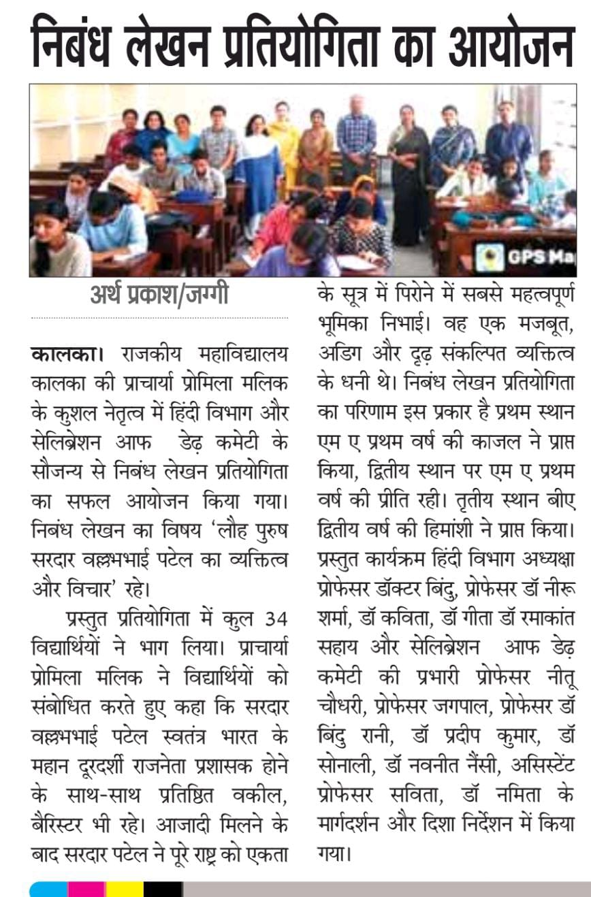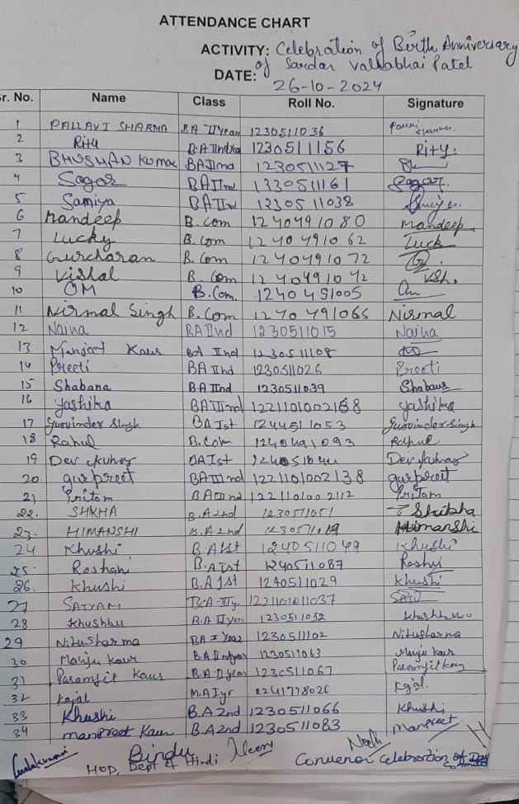

2 | Participation in Talent search competition on Srimad Bhagwad Gita | To promote the teachings of Bhagwad Gita among students | 18-11-2024 | 01 | Increased interest of students in teachings of Bhagwad Gita

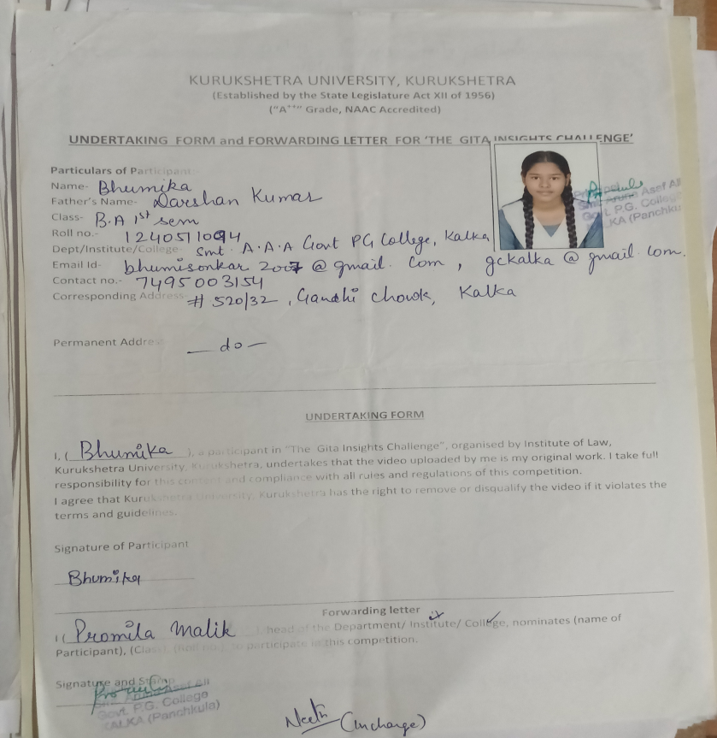

3 | Participation in District youth festival, 2024 at Govt ITI college, sec 14 Pkl | To provide the platform to the students to showcase their talents and explore multidisciplinary fields | 22-11-2024 | 04 | Building confidence of students and one of our student won position in photography
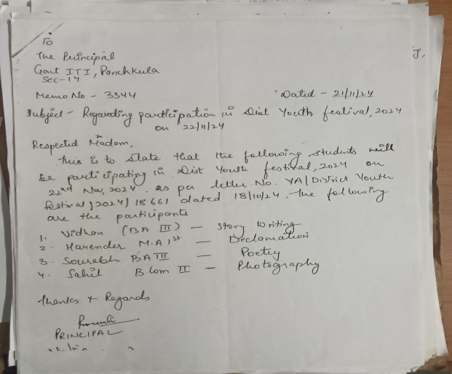

4 | Celebration of Constitution Day(poster making, poetry, essay writing, slogan writing) | To enrich the knowledge of students regarding Constitution of India | 25-11-2024 | 47 | Students read the Constitution and performed very well in the competitions.

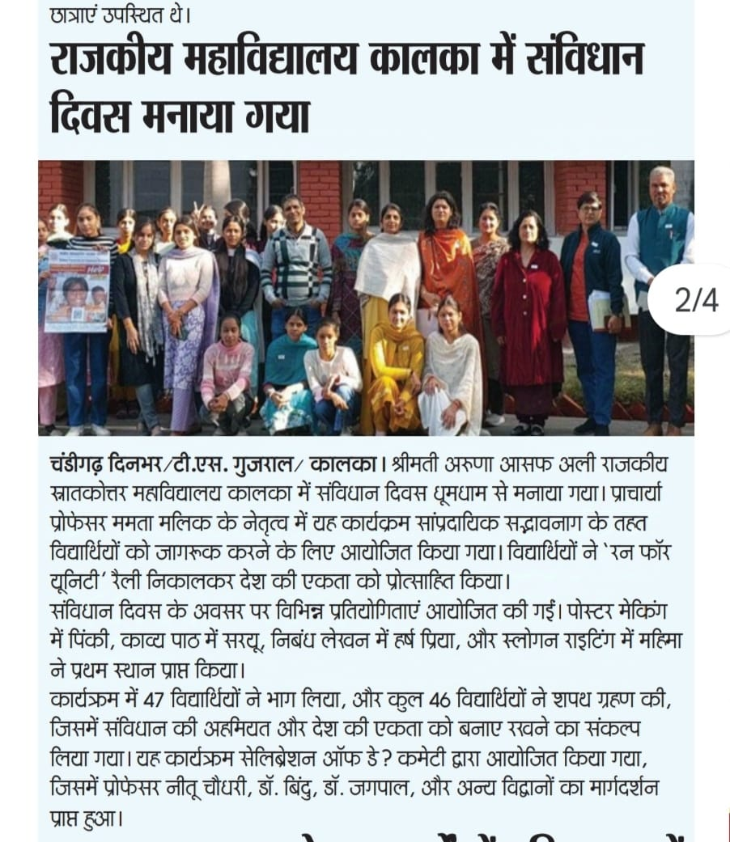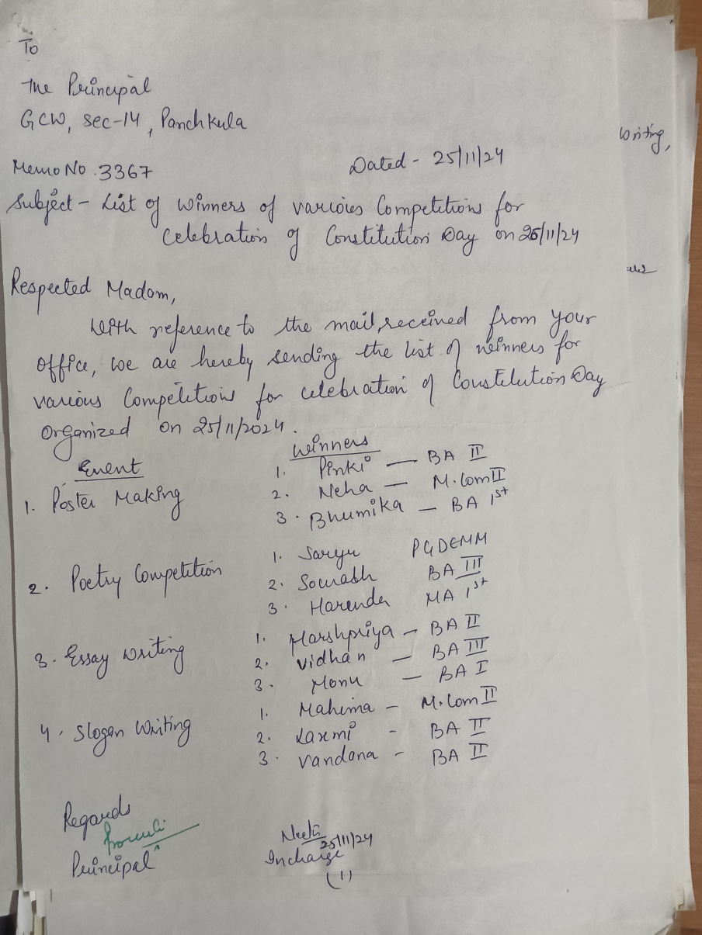

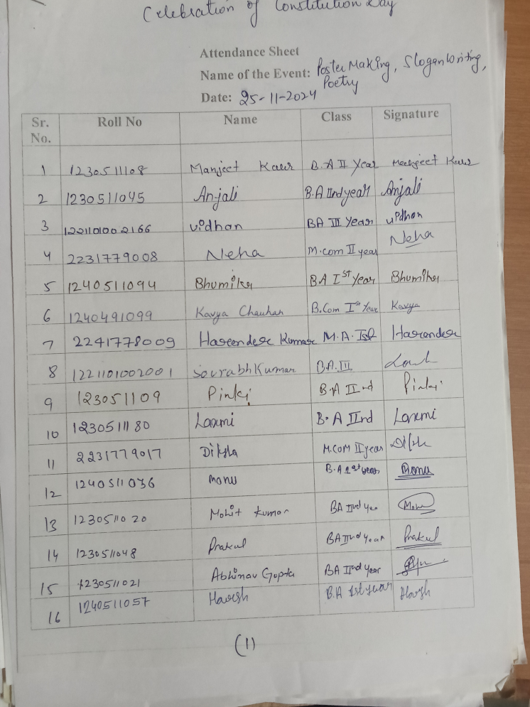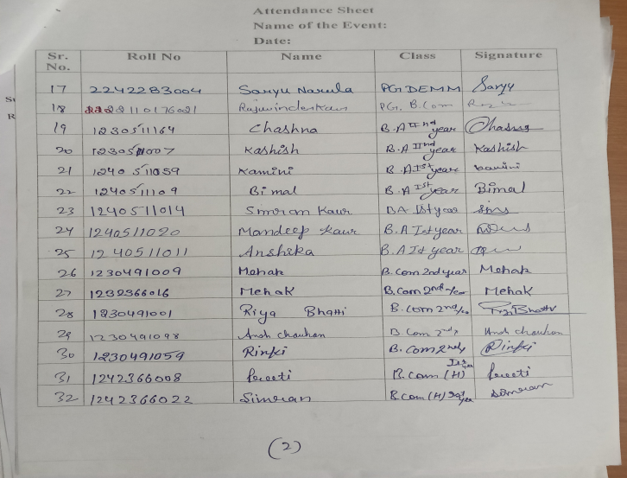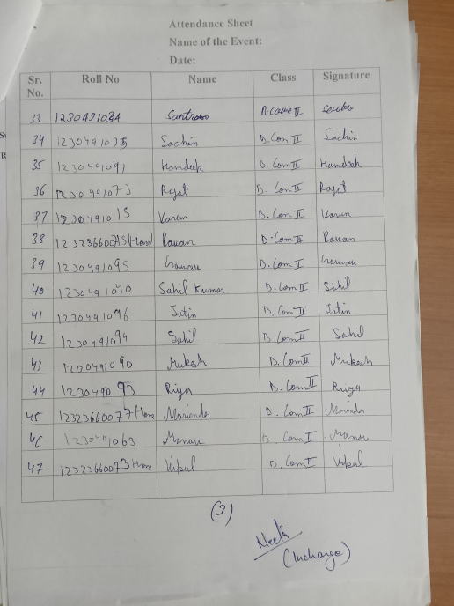

5 | Participation in national youth festival: Viksit Bharat young leaders through online mode | To provide a platform to youth to present innovative ideas and contribute to the vision of Viksit Bharat | 04-12-24 | 30 | Students participated in stage 1 quiz challenge on My Bharat Portal and out of that 25 qualified for second round

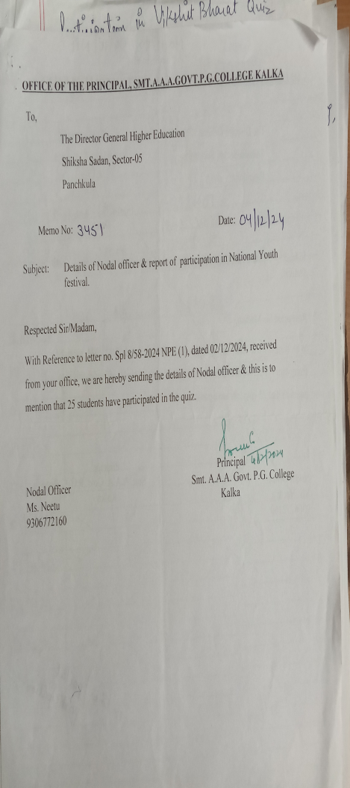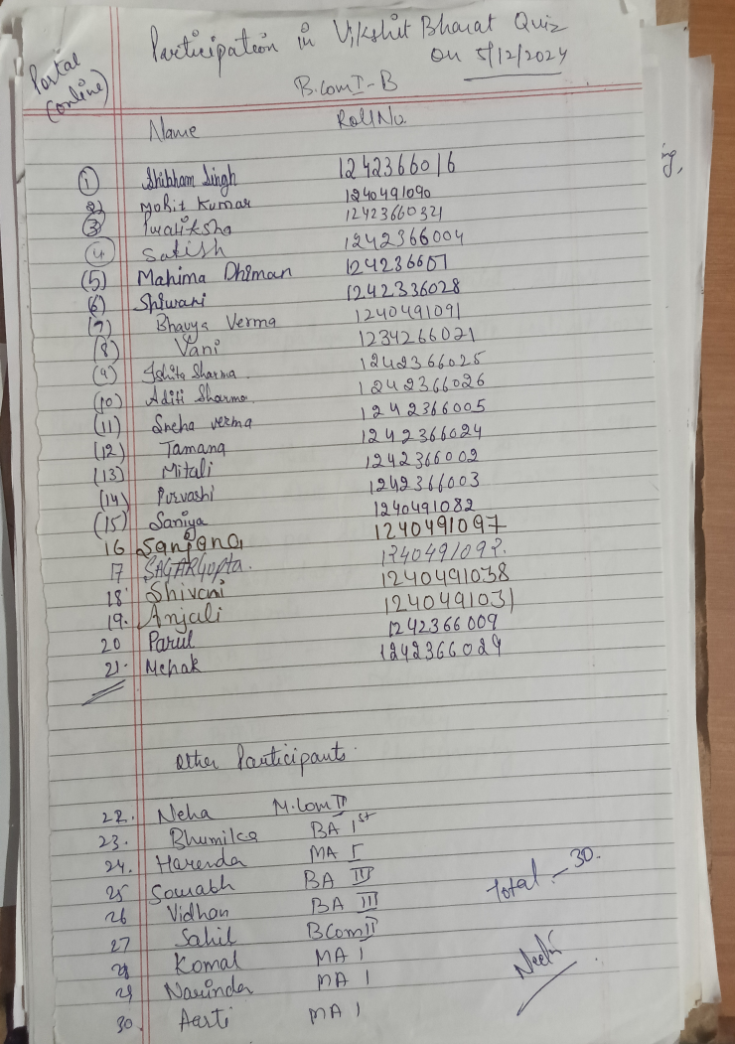

6 | Participation in the recitation of Bhagwad Gita shlokas at GCW sec 14 PKL | To connect with the teachings of Bhagwad Gita and chanting the verses with proper pronunciation and devotion. | 09-12-24 | 02 | It helped the participants to increase mental clarity and spiritual growth.

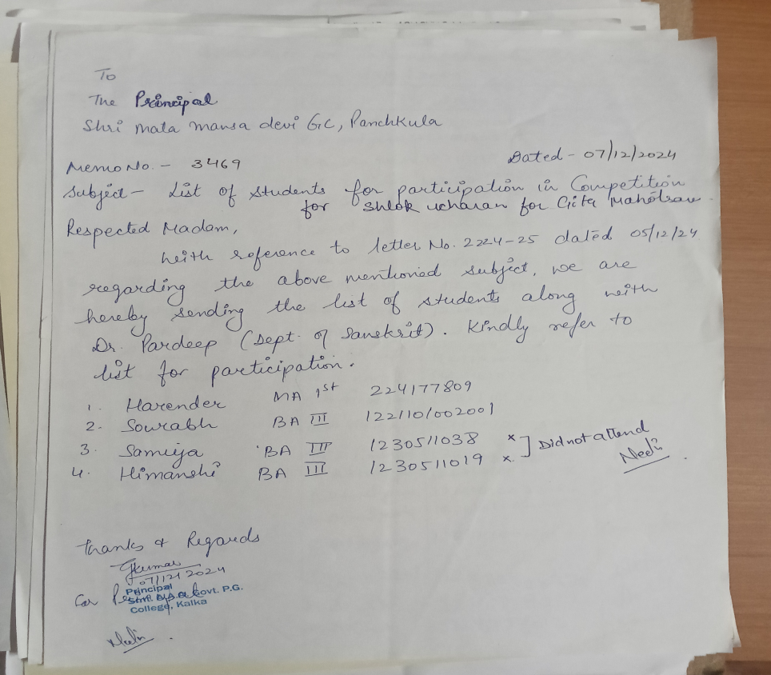

7 | Reading of Preamble to Constitution | To make the students understand the fundamental principles upon which Constitution is based | 17-01-2025 | 45 | Students read the preamble and oath was taken to become the responsible citizen
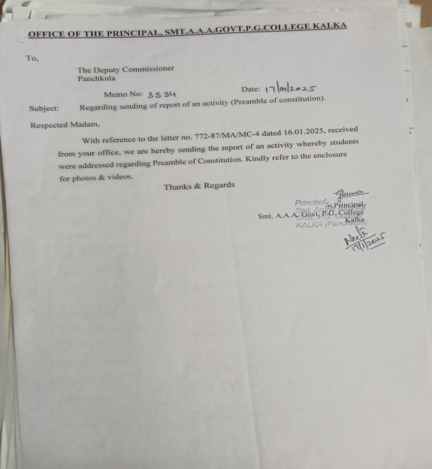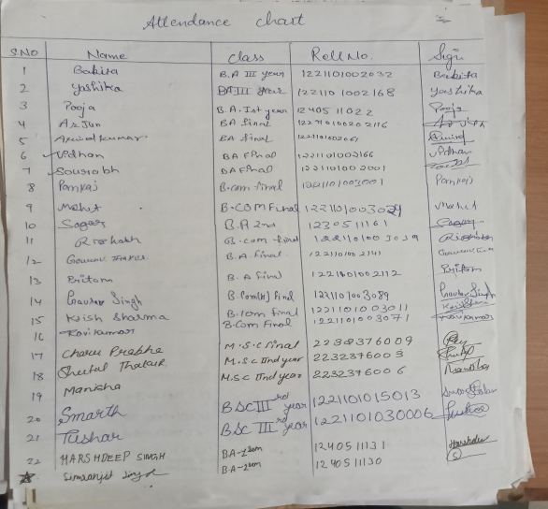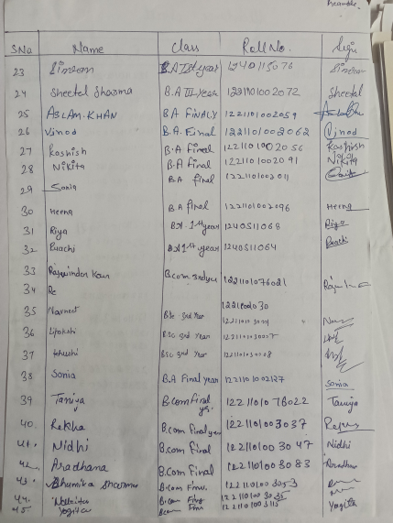

8 | Celebration of birth anniversary of Subhash Chandra Bose | To honour the prominent leader and to make the students aware about his life and contribution in India’s freedom movement. | 23-01-2025 | 26 | Students and faculty members have paid homage to the leader and promised to work towards the nation’s development.

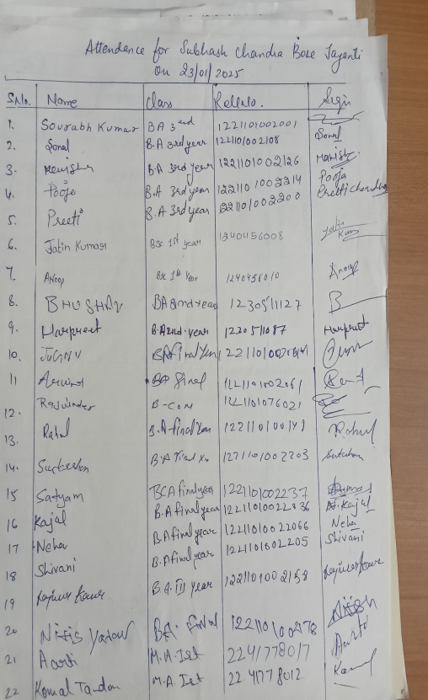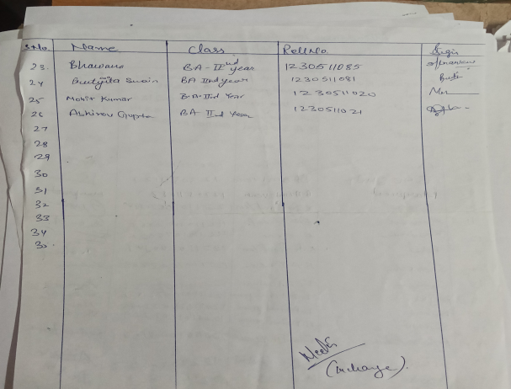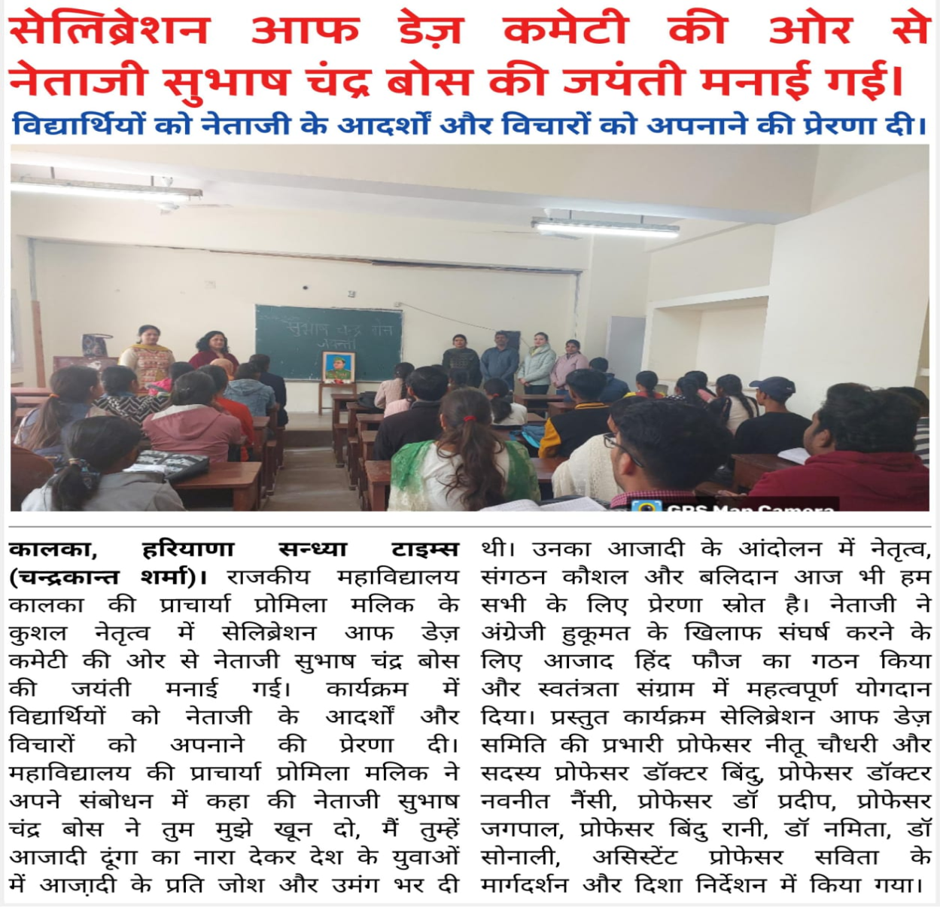

9 | Exhibition of rare manuscripts of Haryana and India | To raise awareness about the rich cultural and historical heritage of the region | 18-02-2025 | 30 | Students were educated about history by showcasing the unique collection of ancient documents.

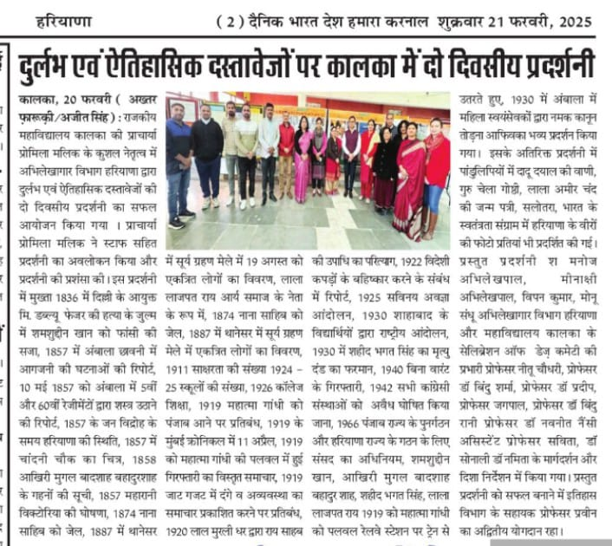

10 | Celebration of birth anniversary of Dr. B.R. Ambedkar (Speech competition) | To honour the contribution of leader to social justice, equality and Indian Constitution. | 15-04-2025 | 15 | Students highlighted the contribution of Dr. B.R. Ambedkar in drafting the Constitution and fighting against injustice and inequality.

