**Placement Cell Activity Report (2022-23)**

1. **Extension Lecture on “Job Prospects and Career Opportunities in Science after Graduation / Post Graduation” organized on 16th Feb 2023. Key Speaker of the Lecture was Dr. Arun Joshi, Retired Principal, Higher Education, Haryana. Approximately 95 students attended the lecture.**

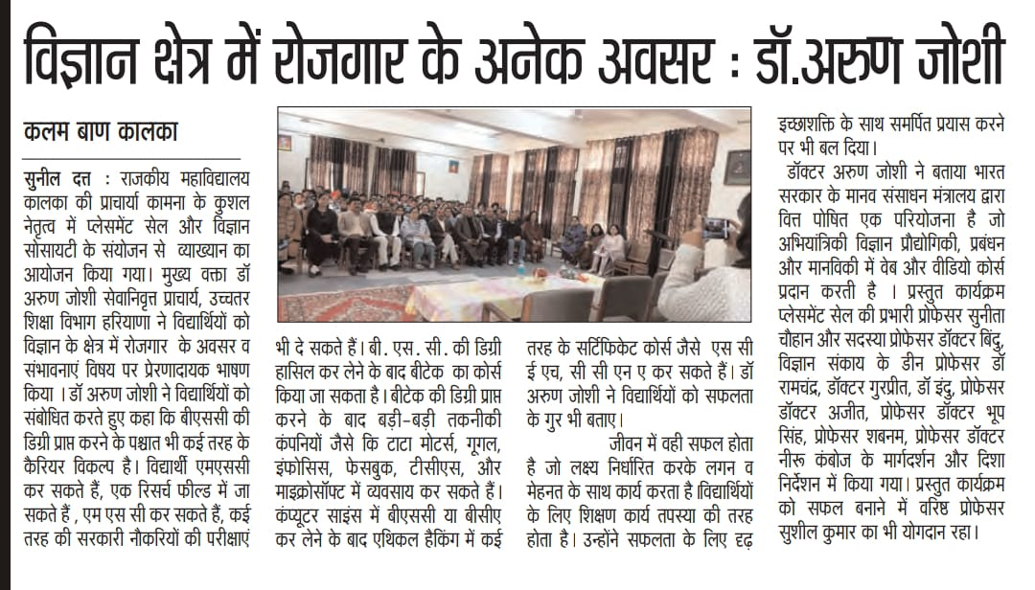

1. **Extension Lecture on “Job Prospects and Career Opportunities in Commerce after Graduation / Post Graduation” organized on 17th Feb 2023. Key Speaker of the Lecture was Dr. Dixit Gupta, Educational Councilor, Chandigarh. 210 students attended the lecture.**

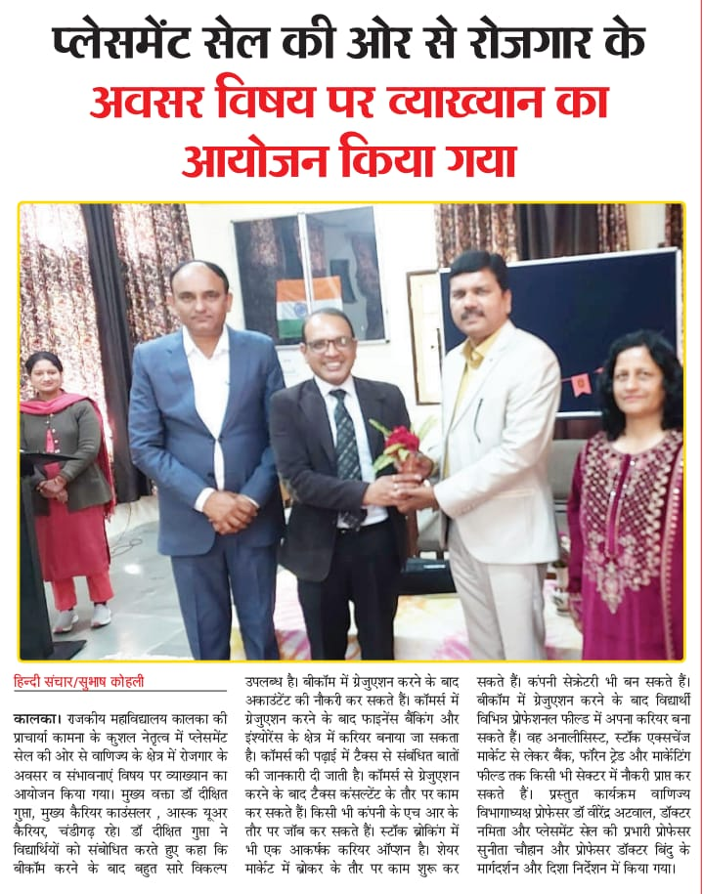

1. **On 1st March 2023 Mr. Vivek Atray (Motivational Speaker), Retired I.A.S Officer Govt. Of Haryana delivered a lecture on “Interviewing Skills and Guidance for Civil Services and other Competitive Exams”. 550 students attended the lecture.**

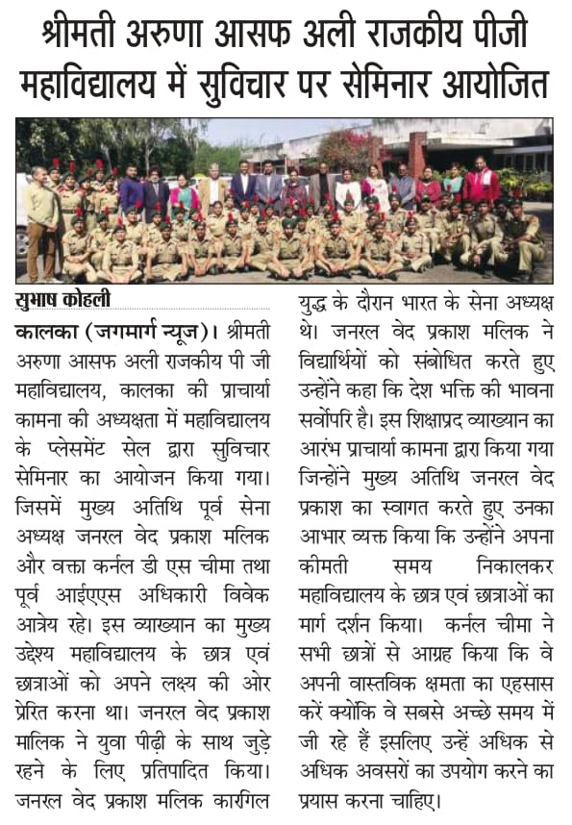

1. **An extension Lecture delievered by Gen. V.P. Malik, Retired Army Chief of India and Col. D.S Cheema, Educationist on 1st March 2023. 550 students attended the lecture.**

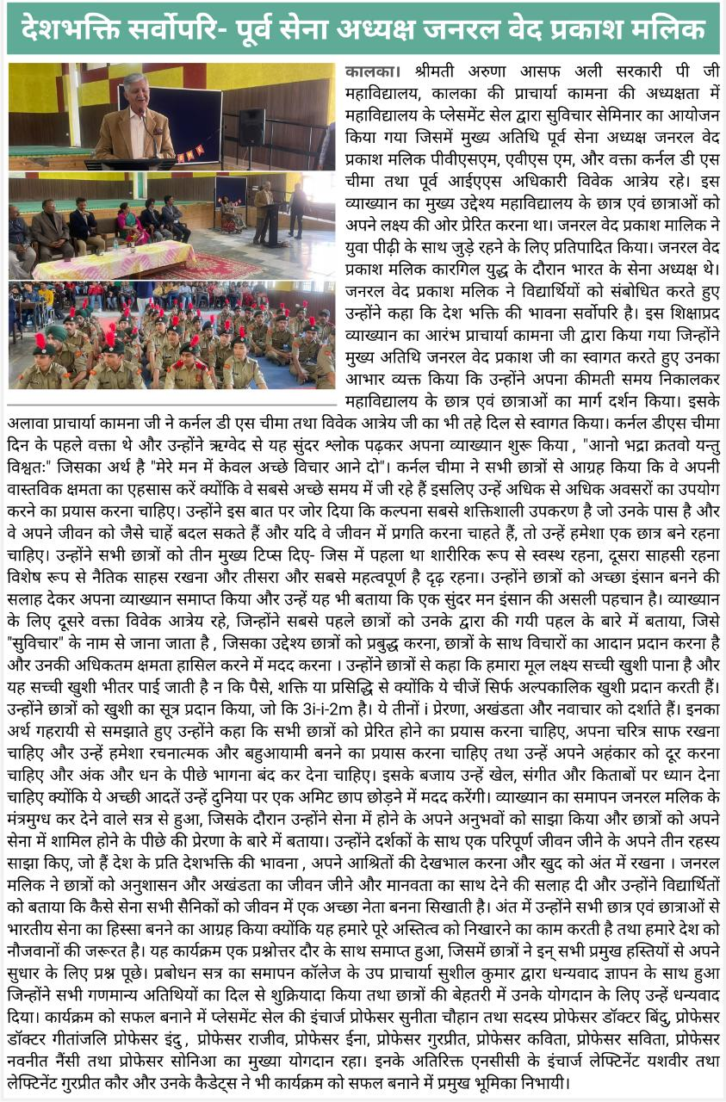

1. **An Extension Lecture organized on 2nd March 2023 on the topic “Success in IELTS and Job Possibilities in Foreign Counteries”. Key Speaker was Mr. Suuny Sharma, Brand Manager IDP Education, Panchkula.**

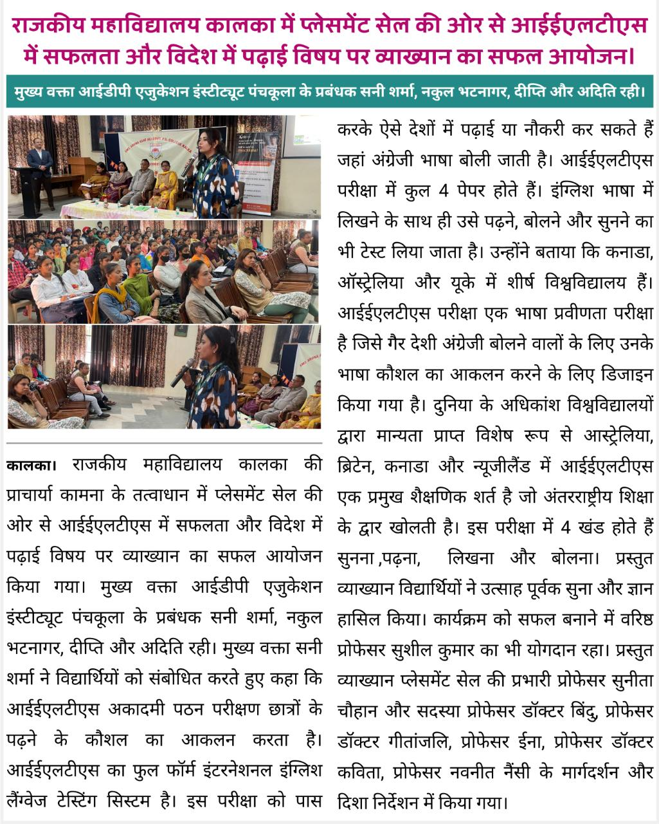

1. **On 3rd April 2023 a Lecture was conducted by Mr. R.K Rao and Mr. Raja Mahendra, Air Force Station Ambala, Recruitment Department on Agniveer Training and Recruitment Process.**

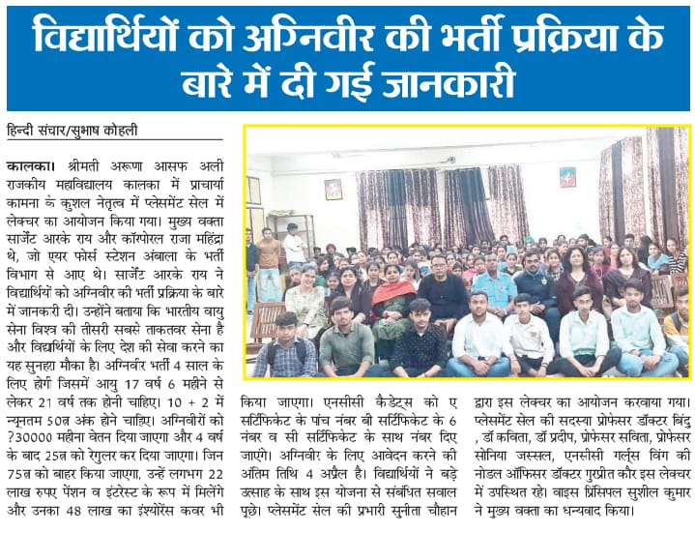

1. **Edureka Learning Center Panchkula delivered a lecture on Cloud Computing, Full Stack Web development, Information Technology and Cyber security on 13th April 2023.**

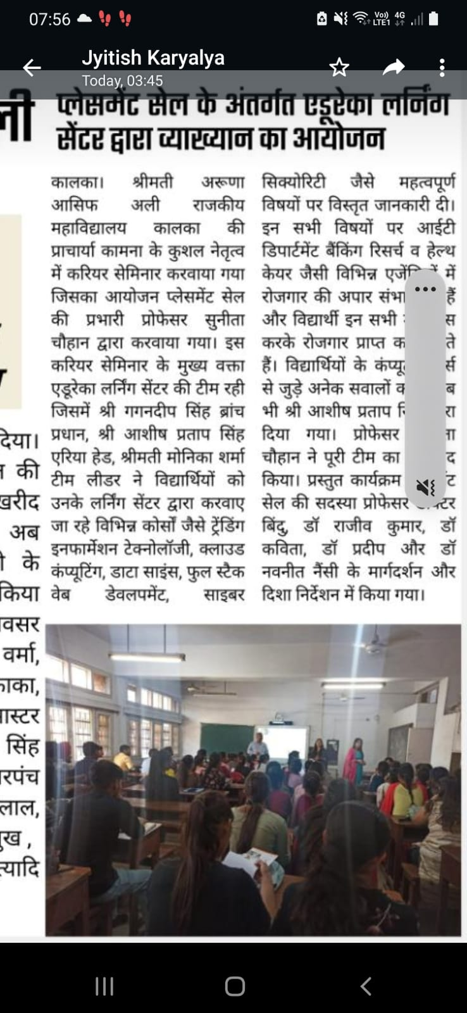

**Dr. Sunita Chauhan**

**Convenor, Placement Cell**